EXPERIMENT -1
ORG 0000H
UP: SETB P2.0
ACALL DELAY
CLR P2.0
ACALL DELAY
SJMP UP
DELAY: MOV R4,#35
H1:MOV R3,#255
H2:DJNZ R3,H2
DJNZ R4,H1
RET
END

OUT PUT

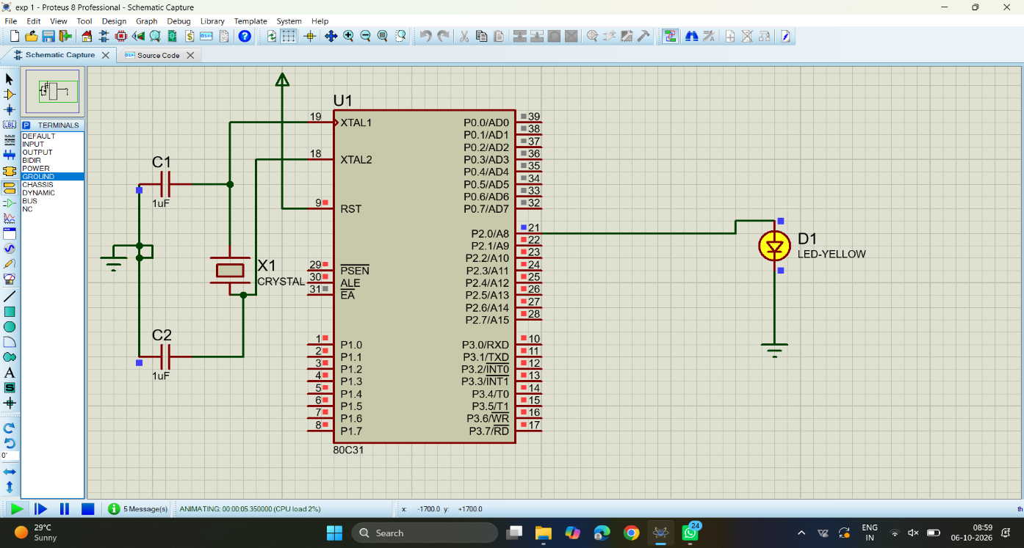
EXPERIMENT 2
CODE:
ORG 0000H
UP: SETB P2.0
ACALL DELAY
CLR P2.0
ACALL DELAY
SJMP UP
DELAY: MOV R4,#35
H1:MOV R3,#255
H2:DJNZ R3,H2
DJNZ R4,H1
RET
END
OUTPUT:

